

**Technical Data Sheet**

|  |
| --- |
| Product: G4 LED Capsule Lamp |

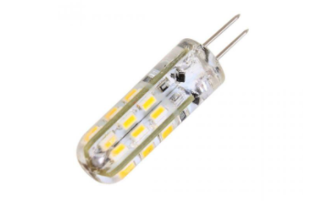

* Ideal Replacement for traditional glass halogen lamp
* LED Life 50000 hrs

|  |  |  |  |  |  |  |  |
| --- | --- | --- | --- | --- | --- | --- | --- |
| Code | Description | Watts | Kelvin | Lumens | Dimensions | IP Rating | Warranty |
| G46LED | 2W G4 FLAT LED | 2 | 3000 | 150 | 33 X 20 X 8 | IP20 | 2 Year |
| G425LED | 2W LED CAPSULE | 2.5 | 3000 | 200 | 39 X 13 | IP20 | 2 YEAR |
| G4220VLED | 220V G4 CAPSULE 2W 3000K | 2 | 3000 | 200 | 45 X 10 | IP20 | 2 YEAR |

