 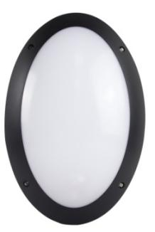

LED DUSTPROOF LIGHTING

|  |  |  |  |
| --- | --- | --- | --- |
| **Parameters** |  |  | **Product Dimension** |
|  | Optical Parameters | | 全圈-线图.jpg |
| CCT | 4000K | | |
| Lumen Output(lm)±5% | 1000lm | | |
| Lumen Efficacy(LPS)±5% | 83.34lm/W | | |
| LED Type/Qt'y | SMD60pcs | | |
| CRI/SDCM | >80/<6 |  |  |
|  | |  | |
| Electrical Parameters | | |  |
| Rated Power(w)±5% | 12W |  | |
| Rated/Actual Input | 180-240Vac | | |
| Driver Output Data | 70Vdc/165mA | | |
| Power Factor/THD/PE | >0.9 |  |  |
| Driver/Connection | IK08 IP66.jpgIntegrated | | |
| Over Load/Short Circuit | Protection | | |
| Hi-pot Test Range | SELV Isolated driver, 3750Vdc/5mA/60S |  | |
|  | Life | |  |
| Warranty | 5 years | | |
| Lumen Maintenance 70% | 40000hrs | | |
| LM80 | 97.34% lumen maintance@6000hrs | | |
|  | Others | |  |
| IP/IK/Glow-wire | IP66/IK08/850℃ | | |
| Temp./Humidity | Working:-20℃~45℃ Storage:<70℃ | | |
| BL24THC.png | BL24THC-1.png |  |  |

**Quality LED Lighting**